The primary information for this document were taken from
https://www.att.com/support/article/email-support/KM1240462
This page informs that GoldMine should not be using a OAUTH but instead is an application similar as Outlook and therefore can use only a Secure Mail Key
https://www.att.com/support/article/email-support/KM1240308 for generating and information about creating a Secure mail key
https://www.att.com/support/article/email-support/KM1086159 for setting up the GoldMine email account based on Outlook 2016 information by AT&T

GoldMine – OAUTH or Secure Mail Key - https://www.att.com/support/article/email-support/KM1240462

‘…
Non-OAuth compatible email apps
- Outlook 2010, 2013, 2016, 2019
- Mozilla Thunderbird
- Windows Mail on personal computers running Windows 8 or older
- Apple Mail/Mac Mail on macOS 10.10/Yosemite or older
We suggest you switch to an email app that has OAuth. Get step-by-step help setting up or updating your email account in several popular email apps, with our Troubleshoot & Resolve Tool.
Get email with an app and a secure mail key
If you prefer to use an email app that isn’t compatible with OAuth, you’ll have to create a special code called a secure mail key. You’ll use this secure mail key instead of your AT&T password when you set up an email app…’

Creating a Secure mail key - https://www.att.com/support/article/email-support/KM1240308

‘…If your email program or app doesn’t have OAuth technology, it will only be able to access your AT&T email program or app using a 16-character secure mail key. Be sure to use myAT&T to create a secure mail key for each of your AT&T email addresses and subaccounts, so you can continue to:
- Access your AT&T email with your favorite email apps
- Synchronize other account info, such as your calendar and contacts, to your email app
…
- Go to Profile > Sign-in info.
- Select the email account that you want to get a secure mail key for. (You’ll find a drop-down menu at the top if you have multiple accounts.)
- Scroll to Secure mail key and select Manage secure mail key.
- If you have more than one email address, select the one you want to use.
- Select Add secure mail key.
- Enter a nickname for the secure mail key to make it easier to recognize.
- Select Create secure mail key.
- Select Copy secure mail key to clipboard. (Jot down your secure mail key, so you have it handy if you have to update an email app on several devices.)
  - For security purposes, the secure mail key only shows until you select OK.
  - If you lose or forget the secure mail key, you can create new secure mail keys as needed.
- Select OK.
- Go to your preferred email app and replace the existing password with your secure mail key. (For an IMAP account, delete the existing password for both the IMAP and SMTP servers and replace them with your secure mail key.)…’

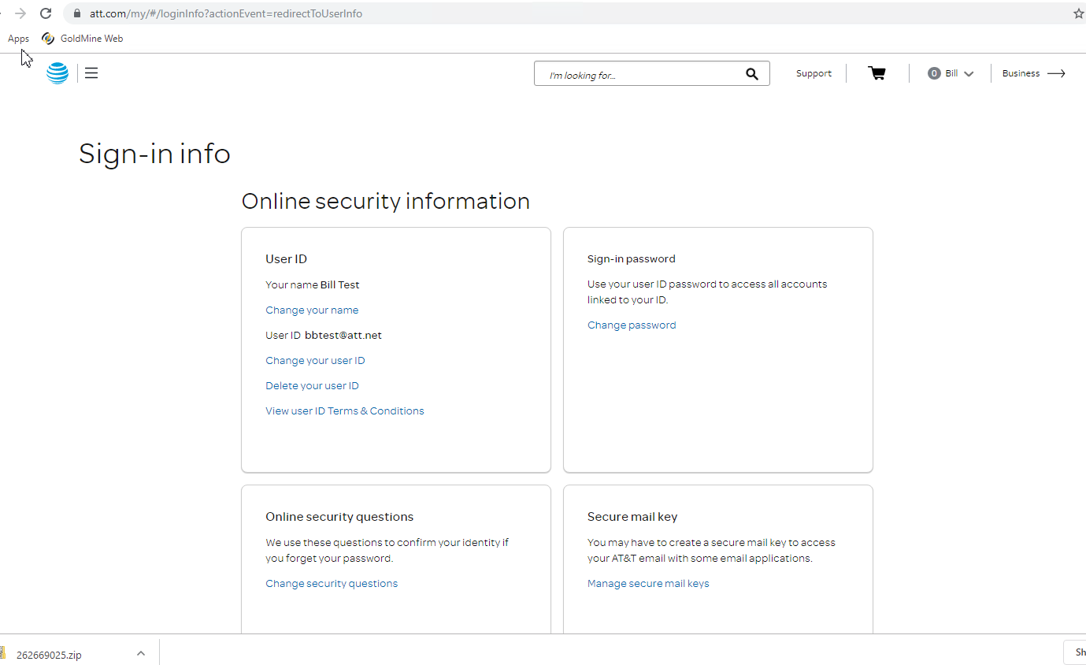

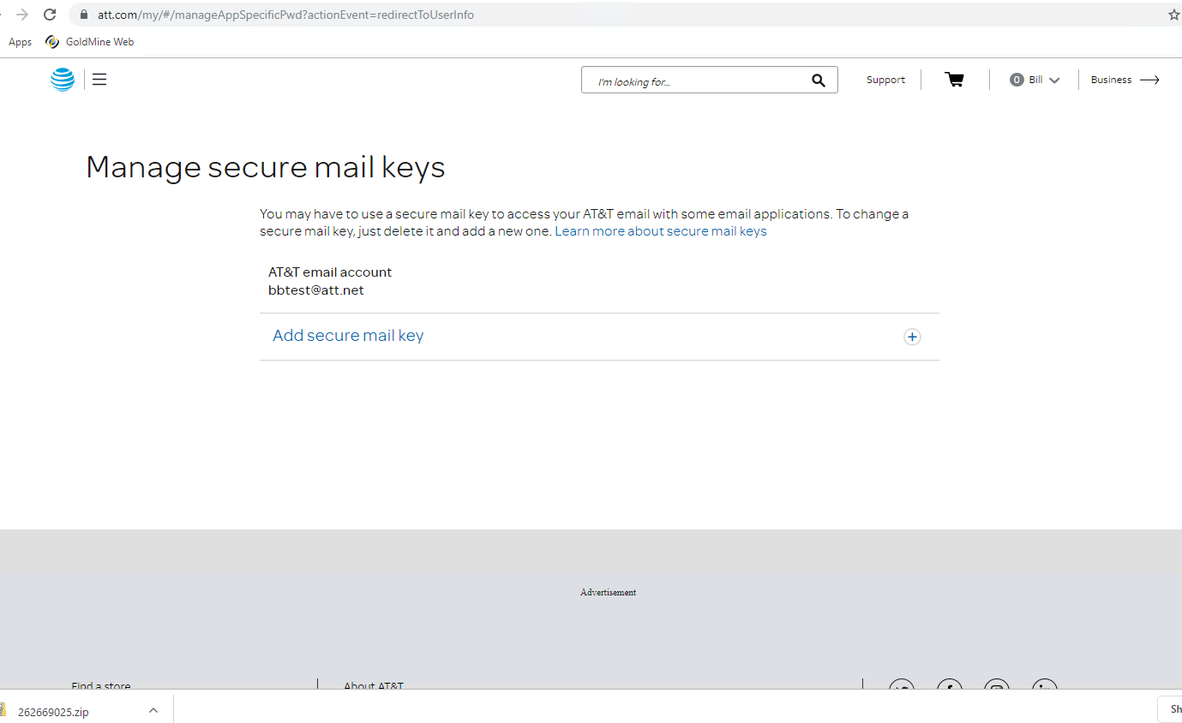
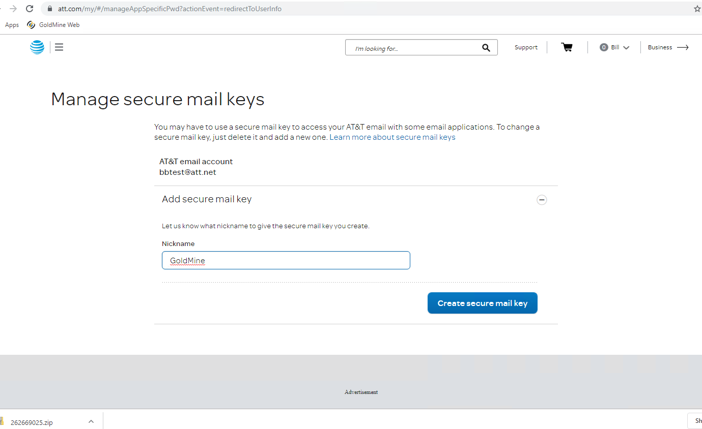

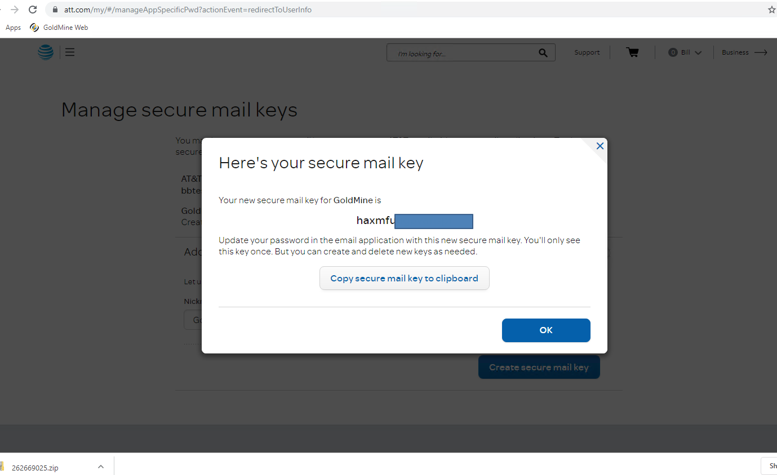
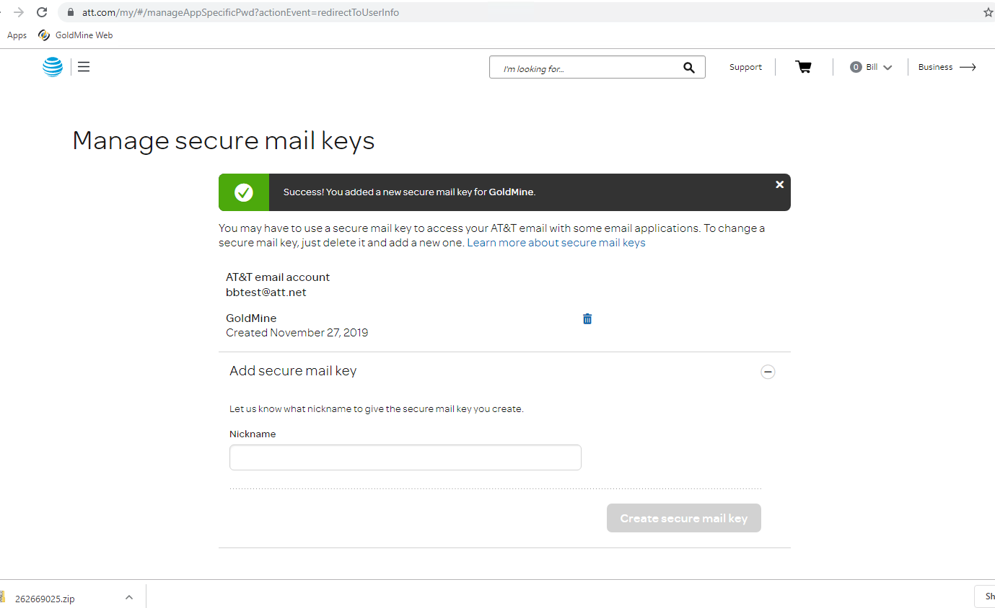

Just changed the password and there is a message

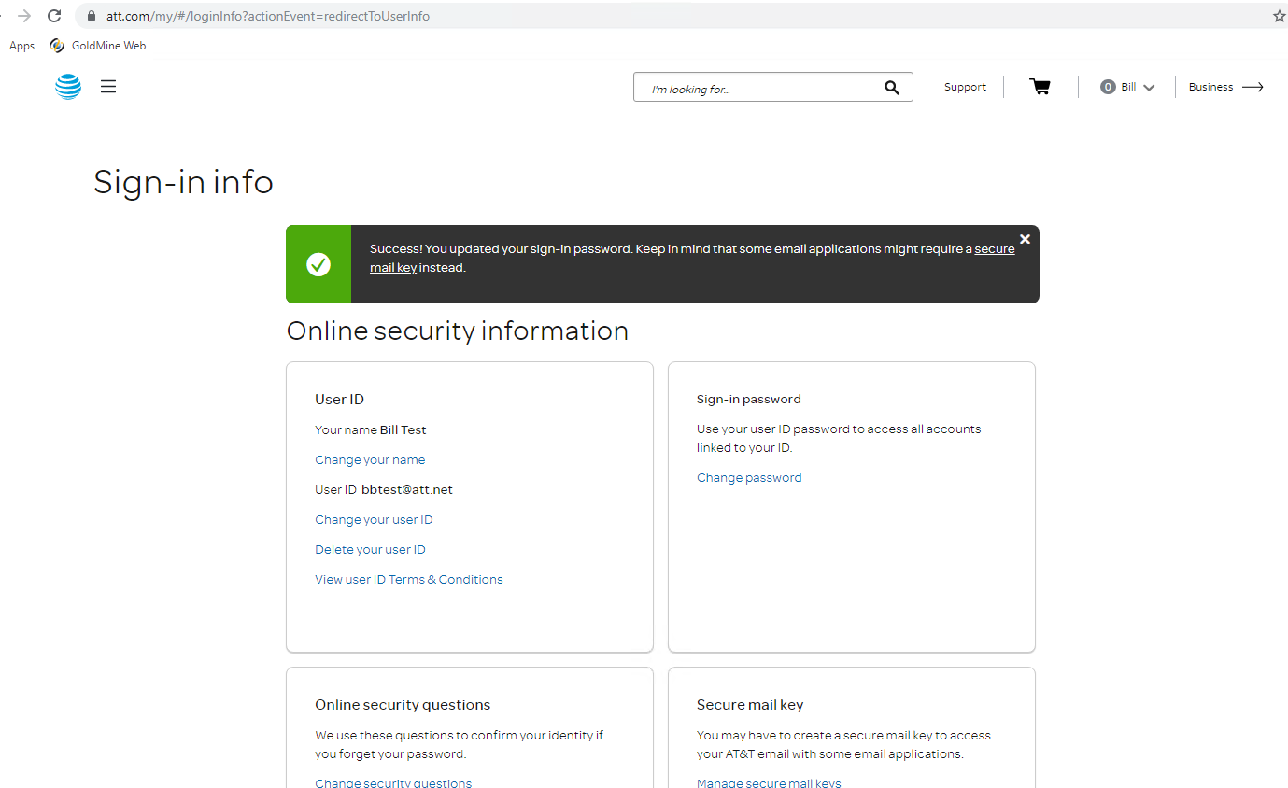

Set up the GoldMine email account based on Outlook 2016 information - https://www.att.com/support/article/email-support/KM1086159

With selecting Outlook 2016 and following the steps (there are a few differences between an Outlook account setup and a GoldMine account setup but in general the necessary information is all there)
