IIS7 blocks access to files in directories of a particular name.

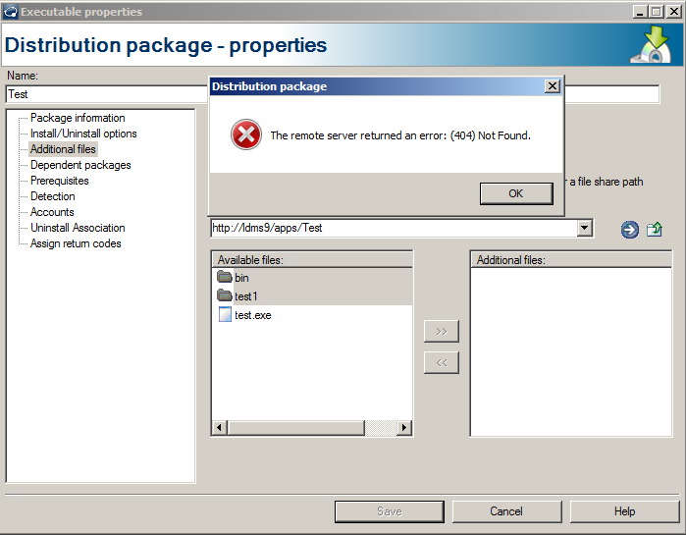

Error

The remote server returned an error: (404) Not Found.

Cause

The error occurs when adding additional files to a package from a web path that contain blocked segment (directories.) This only occurs in IIS 7.0 and above because IIS blocks certain defined segments (directories) in the applicationHost.config file. The lists below are the filtered segments (directories) being blocked.

Web.config
bin

App_code

App_GlobalResources

App_LocalResources
App_WebReferences
App_Data
App_Browsers

Solution

1. To remove the hidden segment form the applicationHost.config add the following near the bottom of the file, with other location tags.
<location path="sitename.com/subfolder/bin/debug">
<system.webServer>
<security>
<requestFiltering>
<hiddenSegments>
<remove segment="bin" />
</hiddenSegments>
</requestFiltering>
</security>
</system.webServer>
</location>
Place the name of the segment to remove from being hidden here.
Add your site name

2. To remove the hidden segment from with the share directory where the packages are stored, place the following lines of code in the web.config file. This is the recommended solution because this only affects the web share where the software distribution packages are being stored.

<?xml version="1.0"?>
<configuration>
<system.webServer>
<security>
<requestFiltering>
<hiddenSegments>
<remove segment="bin" />
</hiddenSegments>
</requestFiltering>
</security>
</system.webServer>
</configuration>
Place the name of the segment to remove from being hidden here.

3. To remove the hidden segment from the applicationHost.config type the following command with the segment (directory) to be removed from being blocked.

C:\Windows\System32\inetsrv\appcmd.exe set config "sitename.com/subfolder/bin/debug" -section:system.webServer/security/requestFiltering /-hiddenSegments.[segment='bin']
Place the name of the segment to remove from being hidden here.

