

Azure SQL Compatibility for Environment Manager & Management Center
Version 2018.3 SP1

Contents
Create a new Personalization or Management Azure SQL Database. 3
Migrate an existing Personalization or Management Server Database to Azure SQL 7
Prepare Personalization Database for Azure SQL: 7
Uploading the Personalization or Management Server Database to Azure: 8
Upgrades of existing Personalization and Management Server Azure SQL Databases 8

Create a new Personalization or Management Azure SQL Database.
  - Create an Azure SQL Resource Group & Server. To do so from the Azure Portal UI you will are required to create a dummy Azure SQL database that can be subsequently deleted if desired:
Logon to the Azure Admin Portal.
Navigate to the 'SQL Databases' menu from within the Azure Portal.
Select the  option and you will be presented with the below form.

Please take note of the Server Admin Credentials as they will be required later in this process:
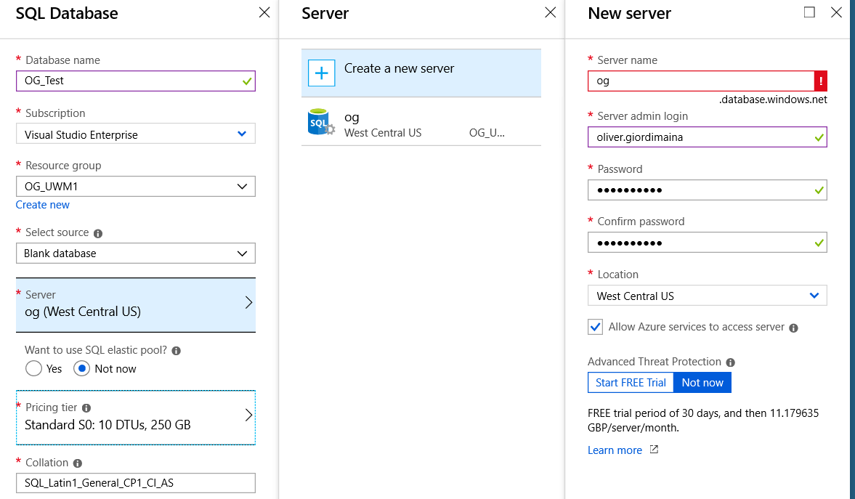

  - Once the form is submitted you will see the Database creation task in progress in the top right corner of the portal, this task could take several minutes.
When the task has completed navigate in to the Resource Group menu and expand the details of the group. Here you will see the Server and Database you have created:
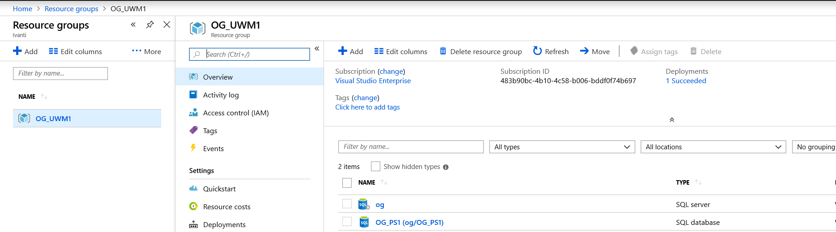

  - Configure a Server level Firewall rule to allow SMSS:
Navigate to the details page of the database created in Step 1 and select 'Set server firewall' from the toolbar: Home > Resource Groups > Group Name > database
Click ‘Add Client IP’ (at the top) to automatically add the public IP address you are communicating from. The IP specified should be that of which any device will utilise when connecting to Azure SQL Server(s) via SMSS.
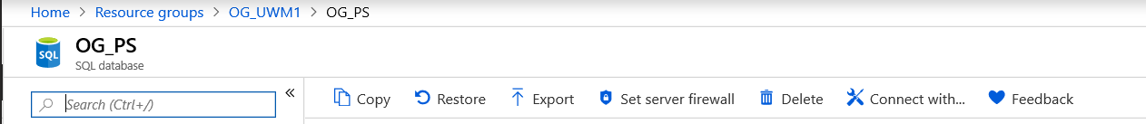

  - With the Firewall rule(s) in place you should now be able to connect to your Azure SQL Server from SQL Server management Studio using your SQL Admin Credentials:
Launch SMSS and when prompted enter the Azure SQL Server name and credentials as created in step 1:
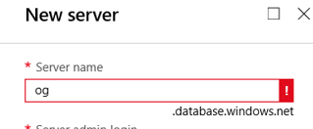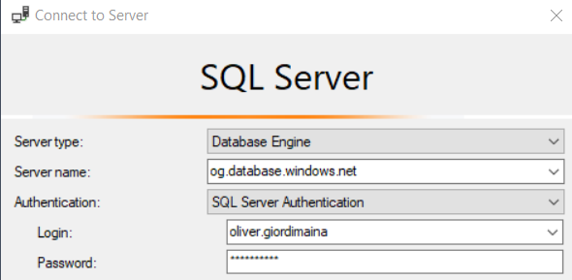

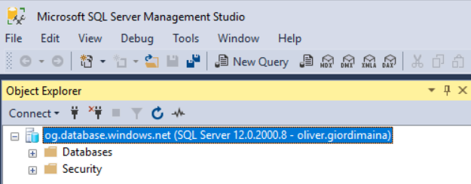

  - Navigate to your UWM management Server and launch the Server Configuration portal. Click on 'Personalization Databases' or ‘Management Databases’ and Create a new Database:
Friendly Name is purely cosmetic.
Server Name is the Azure SQL server name as specified in Step 4 when connecting via SMSS.
Configuration Account is the Azure SQL server Admin Account as specified in Step 4 when connecting via SMSS.
SQL Database Name will be created within Azure SQL by the Server Configuration Portal.
Service Account should be a SQL account and will be created automatically.
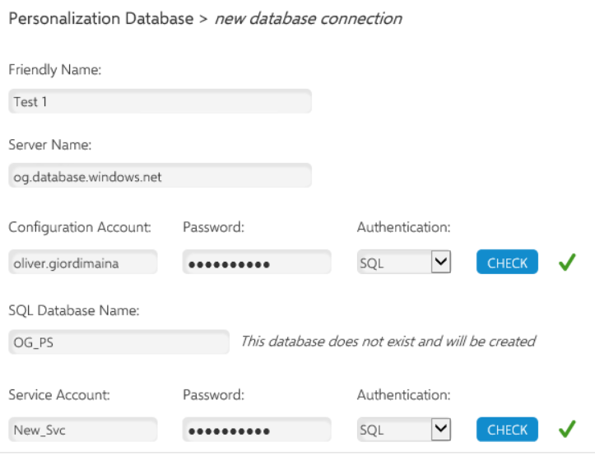

Once created the Database will be present as a database connection for any local or remote instances:
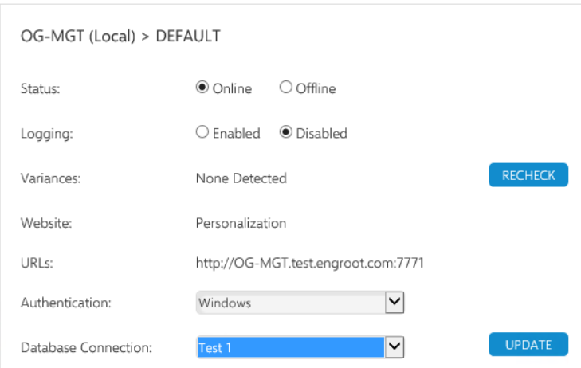

  - Return to the Azure Portal and the new Database will now be present.
Home > Resource Groups > Group name:
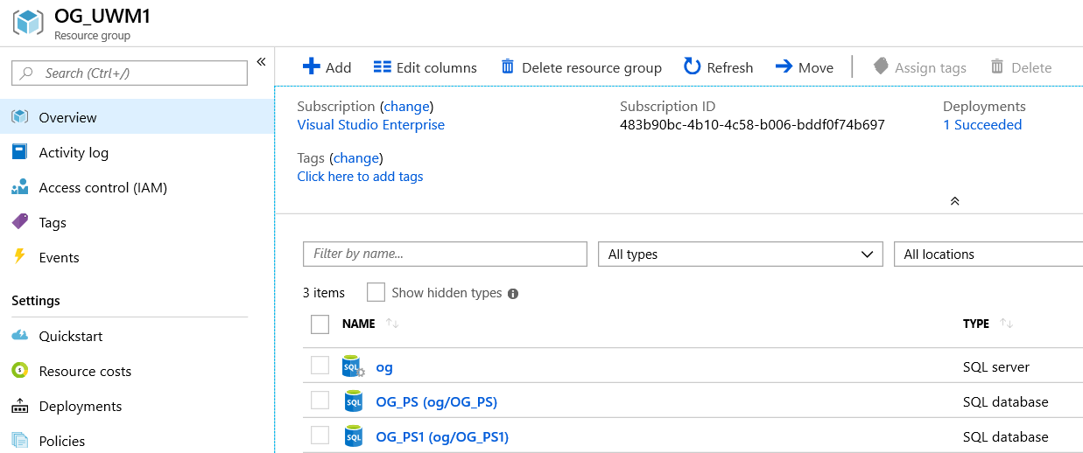

Migrate an existing Personalization or Management Server Database to Azure SQL
To migrate and upgrade an existing PS database to Azure it must be modified by the attached script and then migrated by means of SQL Server Management Studio (SSMS).
* Management Server Databases do not require any preparation, please skip to step 5.

Prepare Personalization Database for Azure SQL:
- If you are using an existing database which needs to be preserved, back it up and restore the backup to a new database for migration. Databases with SQL Merge Replication or GeoSync enabled cannot be converted for Azure - these features must be disabled first. Note that it is not possible to copy a merge-replicated database and disable replication on the copy, as some replication artifacts are not cleaned up.
- Ensure you have the latest version of SSMS, which has the Azure connectivity features. This can be downloaded from https://docs.microsoft.com/en-us/sql/ssms/download-sql-server-management-studio-ssms. It is not necessary to uninstall previous versions of SSMS.
- The PS database must have a schema version of at least 10.1.133. This corresponds to software version 10.1 FR3. If the existing database is earlier than that, it needs to be upgraded by installing a 10.1 FR3 or later version of the Personalization Server and upgrading through the Server Configuration Portal (SCP).
- The database is prepared for Azure by running the PrepareForAzure.sql script shipped with the UWM Suite Release media. By default, the script required will be extracted to the below location on your UWM management server:
C:\Program Files\AppSense\Environment Manager\Personalization Server\Support\Scripts
If you are running this script through SSMS note that SQLCMD mode must be enabled in the query menu before running it. This script does the following:
  - Removes the ArchiveData filegroup - Azure SQL only supports a single file group. If the database contains archive data this can take a considerable amount of time (view the message tab in SSMS to view progress)
  - If they exist, removes the SQL Message Broker objects used by the fixed part of GeoSync - in current PS versions these are present regardless of whether the GeoSync feature was enabled and are not supported in Azure SQL.
  - AuthorizedUsers and server records are removed
  - Non-contained database users are removed

Uploading the Personalization or Management Server Database to Azure:
- Find the local database to be migrated in the SSMS object explorer. If this is a PS database, it must have been prepared as described above.
- Right-click and under 'Tasks' select 'Deploy database to Microsoft SQL Azure database'.
- When prompted for ‘Server Connection’ add your Azure SQL Server instance.
- Complete the Wizard with default preferences. The Database will now be present in Azure and available for connections.

Upgrades of existing Personalization and Management Server Azure SQL Databases
Upgrades can be handled from the SCP in the same way as On-Premise Databases. Note that the machine running the SCP and servers needs to have access to the Azure SQL instance by means of a server level firewall rule (as described above).

