HEAT AirGap Management Tool 8.5
  - KB Article
Impact: HEAT EMSS 8.5 servers configured as disconnected AGMT Airgap Clients. Recently deployed servers may not experience this problem.
Symptoms: The AirGap Management Tool 8.5 installer fails when attempting to install HEAT_AGMT_Setup.exe. The following error is displayed by the installer:
0x800b010a – A certificate chain could not be built to a trusted root authority.
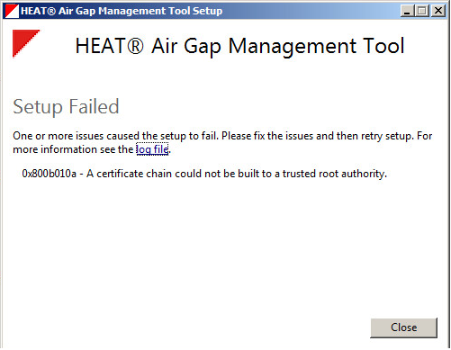
Root Cause: The local machine’s Trusted Root Certificate Authorities has not been updated by the windows update service. Disconnected air gap servers cannot connect to the internet to receive periodic updates from this service. When new trusted root certificate authorities are added or when known trusted root certificate authorities become invalid (expired) or eve revoked the certificates cannot be updated in the trusted certificate authorities store. When the installer runs a path cannot be constructed from the HEAT code signing certificate to its root authority resulting in this failure.
NOTE: Recently deployed EMSS servers inside the airgap may have already been updated during build-up. These servers may not experience this failure.
Solution: Since automatic root updates are not available in the airgap environment, Administrators must manually manage trusted root certificate authorities that are trusted by Windows. New and updated root authorities can be manually added to the server using the mmc snap-in “Certificates” to import a file containing them.

How to Get - Trusted Root Certificate Updates
On the HEAT EMSS 8.5 server configured as the connected AGMT Airgap Provider:
- Logo as Administrator.
- Create a new folder <Cert_Updates_Dir> in a convenient location. This folder will receive the new Trusted Root Certificate update files.
- Open a cmd.exe window.
- Enter on the command line “certutil –syncwithwu <Cert_Updates_Dir>”. You should see something similar to this”
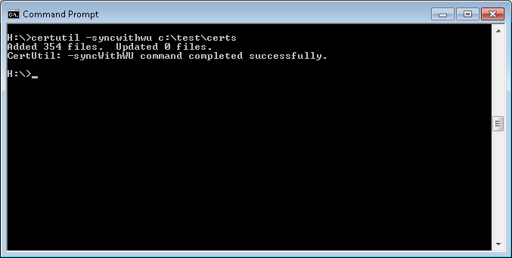
From the above example the folder c:\test\certs was filed with certificate files. The folder also contains two cab files “authrootstl.cab” and “disallowedcertstl.cab”.
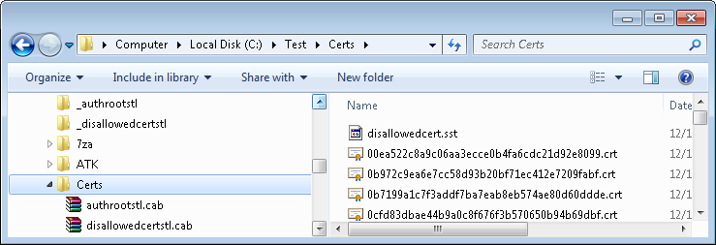
These cab files each contain one file. The authrootstl.cab file contains the file “authroot.stl” which is a list of current Trusted Root Certificate Authorities trusted by Microsoft. The second cab file “disallowedcert.stl” is a list of revoked Trusted Root Certificate Authorities.
- Extract the two .stl files from their respective cab files. These files will be used to update the trust lists on disconnected AGMT Clients. Move these files into the airgap.
NOTE: Care should be taken to secure these files when they exist outside the airgap. These files represent an opportunity for bad players to introduce bogus certificate authorities.

How to Update - Trusted Root Certificate Updates
On the HEAT EMSS 8.5 server configured as the disconnected AGMT Airgap Clients:
- Logon as Administrator.
- Click <Start>.
- Click <Run>.
- Enter “mmc”.
- You will be using the consoles “Certifiactes” snap-in. If it not already available in the console tree, Click File>>Add/Remove Snap-in and add the “Certificates” snap-in to the console.
- Double Click “Certificates (Local Computer) in the console tree.
- Double Click “Certificates”.
- Right Cick “Certificates” and click All Tasks>>Import. The certificate import wizard is now visible.
- Click <Next> and use the browse button to select the “authroot.stl” file.
- Select to place the certificates in the Trust Root store.

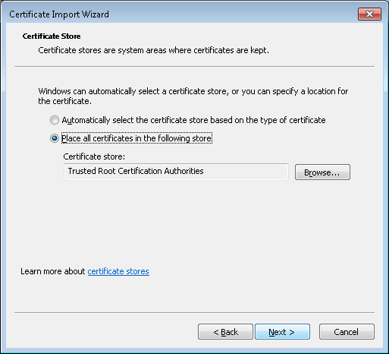
- Click <Next>.
- Click <Finish>.
- Once the import operation has completed repeat the import process from step 9 above import the “disallowedcert.stl file..
The updated Trusted Root Certificate Authority list is now ready and available to the HEAT_AGMT_Setup.exe installer. Re-run the installer to install AGMT 8.5
NOTE: Distributing trust list updates within the airgap can be accomplished by repeating this process on each AGMT client I the airgap or distribution through the use of group policy if airgap clients are enrolled in an airgapped domain.
For more information about how to manage the root certificates that are trusted by Windows, visit the following Microsoft website: https://technet.microsoft.com/en-us/library/cc754841.aspx

