How to solve the “fastprox.dll” error at Windows 7 deployment using a WinPE 4 Boot Environment

Issue: The OS deployment of Windows 7 x64 stops with error „The procedure entry point ??0WString2@@QEAA@XZ could not be located in the dynamic link library X:\Windows\system32\wbem\fastprox.dll" when using a WinPE 4.0 Boot Environment.

Resolution: This is due an incompatibility of the WinPE 4.0 Boot Environment sources and the Windows 7 setup files. You need to replace the fastprox.dll in the WinPE 4.0 Boot Environment.

Here are the steps create a special WinPE 4.0 x64 Boot Environment:

- Open the DSMC and select the Software Library

- Browse an existing WinPE 3.0 x64 Boot Environment and select “View package directory” 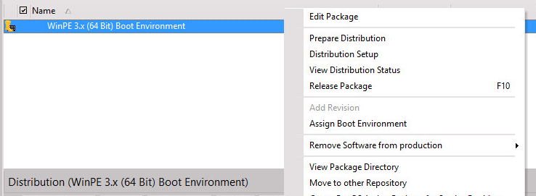

- Browse to the winpe30.wim in the Extern$ directory and note the path of the winpe30.wim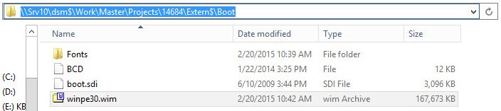

- Open the Windows Explorer and create a folder “C:\WINPEMOUNT”

- Open a command line with current path “C:\Program Files\Windows AIK\Tools\amd64\Servicing\”. Please note, this path is only available if the Windows Assessment and Deployment Kit (Windows ADK) is installed.

- Run the following commands:
  - Dism.exe /mount-wim /wimfile\\Srv10\dsm$\Work\Master\Projects\14684\Extern$\boot\winpe30.wim
/index:1 /mountdir:C:\winpemount
  - copy C:\WINPEMOUNT\Windows\System32\wbem\fastprox.dll C:\temp\fastprox.dll
  - dism.exe /unmount-wim /mountdir:C:\WINPEMOUNT /discard

- In the DSMC Software Library, create a new WinPE 4/5 Boot Environment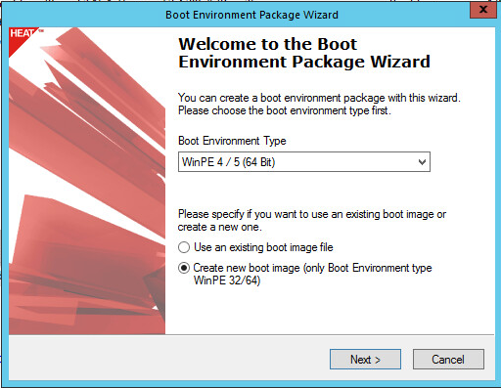 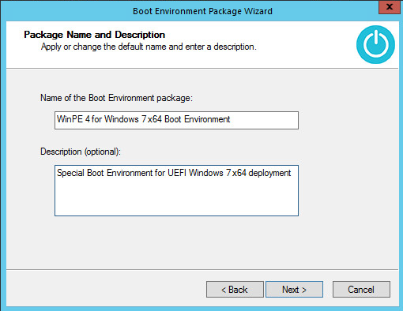

- After the WinPE 4/5 Boot Environment has been created, select “View Package directory” 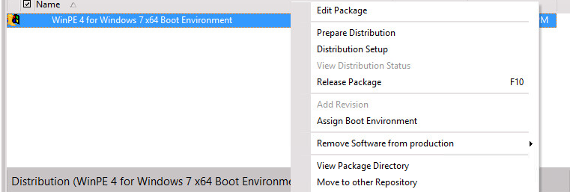

- Browse to the winpe40.wim in the Extern$ directory and note the path of the winpe40.wim.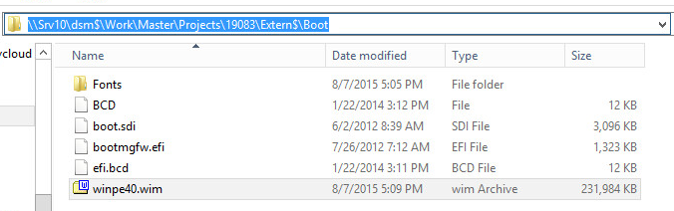

- Go back to the command line and open the path “C:\Program Files\Windows AIK\Tools\amd64\Servicing”

- In the command line, run the following commands:
  - Dism.exe /mount-wim /wimfile:\\Srv10\dsm$\Work\Master\Projects\19083\Extern$\Boot\winpe40.wim
/index:1 /mountdir:c:\winpemount
  - takeown /F C:\WINPEMOUNT\Windows\System32\wbem\fastprox.dll
  - icacls.exe C:\WINPEMOUNT\Windows\System32\wbem\fastprox.dll /grant everyone:F
  - ren C:\WINPEMOUNT\Windows\System32\wbem\fastprox.dll fastprox.dll_old
  - copy C:\temp\fastprox.dll C:\WINPEMOUNT\Windows\System32\wbem\fastprox.dll
  - dism.exe /unmount-wim /mountdir:C:\WINPEMOUNT /commit
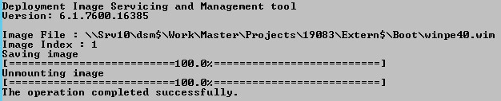

- Prepare the distribution of the WinPE 4/5 Boot Environment package and run the distribution setup

- Using 7-Zip, you may verify the modified image has been distributed to the install folder (e.g. \\Srv10\dsm$\Install\Master\Projects\19083\rev\1\Extern$\Boot\winpe40.wim\Windows\System32\wbem\)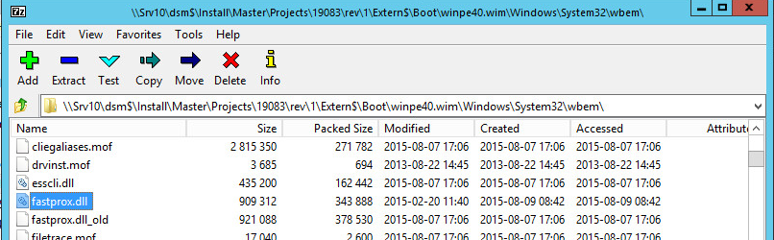

- Now copy your existing “Windows 7 Domain - OS Configuration Package” and adapt the Boot Environment Type. As this is a special OS Installation Set, please consider to set a fixed Boot Environment Link too. 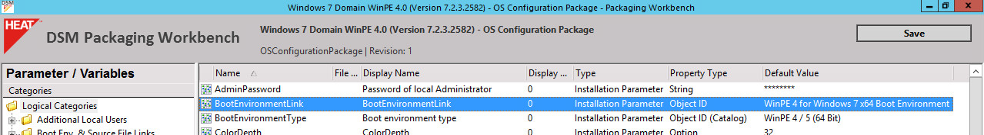

- Prepare the distribution of the “Windows 7 Domain - OS Configuration Package” and run the distribution setup. Wait until the distribution is completed.

- Now copy your “Windows 7 (x64) Enterprise – OS Installation Set” and replace the “Windows 7 Domain - OS Configuration Package” in the new OS Set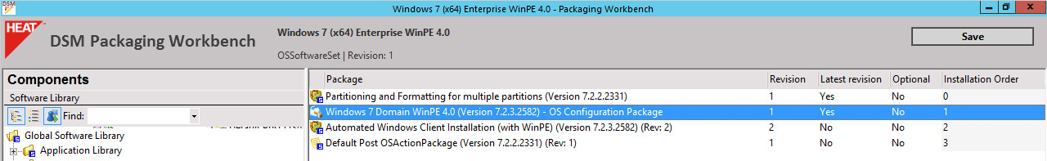

- Assign the new “Windows 7 (x64) Enterprise – OS Installation Set” to a test client and verify the OS deployment is successful