Configuring the HEAT Messaging Center XML Listener

Table of Contents
Creating a Basic Example XML File 3
Configure the XML Listener 4
Configure the Filters and Actions 8

Creating a Basic Example XML File
- Open Notepad.
- Copy the following text into the Notepad.

<?xml version="1.0" encoding="iso-8859-1" ?>
<CreateTicket>
<DataItem CustID="MHendric" Priority="3" Status="open" CallDesc="This is a ticket created from the first line in the XML file" GroupName="Administrator" CallType="Email"/>
<DataItem CustID="BLaw" Priority="3" Status="open" CallDesc="This is a ticket created from the second line in the XML file" GroupName="Administrator" CallType="Email"/>
</CreateTicket>

- Save the file as [FileName].XML

Configure the XML Listener

- Login to HEAT Messaging Center.
- Under Message Sources, click on the XML Listener.
- Under the General Settings tab click on Add.

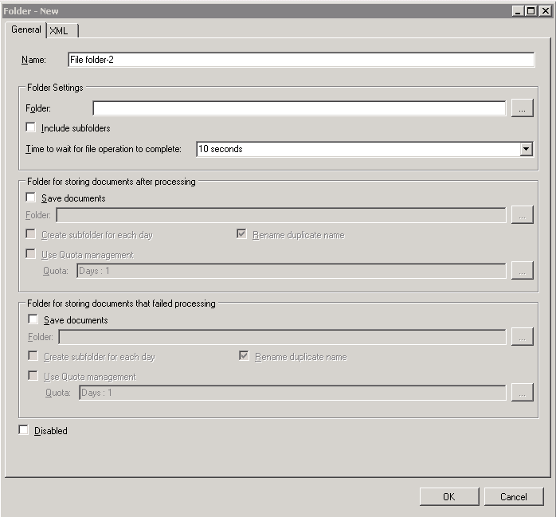

- Name the Configuration on the General tab of the Folder – New window:
- Set remaining below options for the General tab.
  - Folder Settings
    - Folder: The source for files to be processed. This may be a local path or a UNC path. If a UNC path is to be used the HEAT Messaging Center XML File Listener service must be configured for a specific login with rights to the share.
    - Include subfolders: Will scan all the subfolders for XML files that can be processed.
    - Time to wait for the file operation to complete: The amount of time it will read the file and attempt to process before labeling as Failed.
  - Folder for storing documents after processing
    - Save documents:
Folder: This can also be a UNC path, again the service must contain a valid domain account to access the share. This setting is not required.
    - Create subfolders for each day: This will create a new subfolder for each day that a file is successfully process (date format will be used)
    - Rename duplicate name: If a file with the same name as one already in the processed folder, this function will rename the file to avoid errors.
    - Use Quota management: Identifies which files to delete. Determined by age (in days) or size (in MB).
  - Folder for storing documents that failed processing
    - Save documents:
Folder: XML Files that have failed processing due to incorrect configuration or an action that was not completed. This can also be a UNC path; again the service must contain a valid domain account to access the share. This setting is not required.
    - Create subfolders for each day: This will create a new subfolder for each day that a file is successfully process (date format will be used)
    - Rename duplicate name: If a file with the same name as one already in the processed folder, this function will rename the file to avoid errors. It is highly recommended that this box remain checked as duplicates that are not renamed could cause the service to fail.
    - Use Quota management: Identifies which files to keep. Determined by age (in days) or size (in MB)

- Under the XML tab
  - Click on the Open XML file icon
  - Browse out to the XML file you created earlier, and open it.
  - Once open you can then expand the CreateTicket section, and the DataItem section
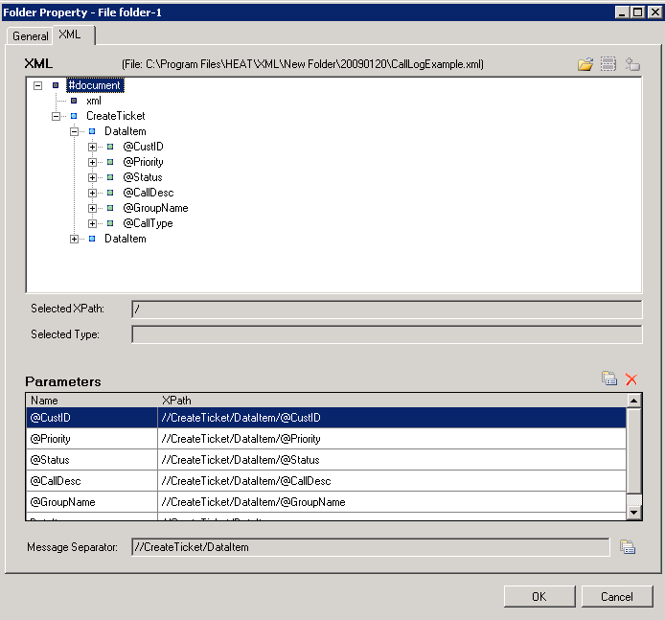

- Under the DataItem section you will see each of the fields declared as a @VARIABLE.
- Right-click on each of these variables and select Add Parameter.
- This will add each of the variables to the mapping below. (This is the step that allows you to use that variable in the Actions for the XML schema).
- Right click on DataItem and select Add Message Separator (This identifies the separation of each set of data to be entered).

- Click OK.
- Click on the Message Storage tab.
- Enter the information for your message storage database used for HMC.
- Click on the red Save icon

Configure the Filters and Actions

- When using the XML Listener and creating a filter, ensure that you change the schema to .XML File.

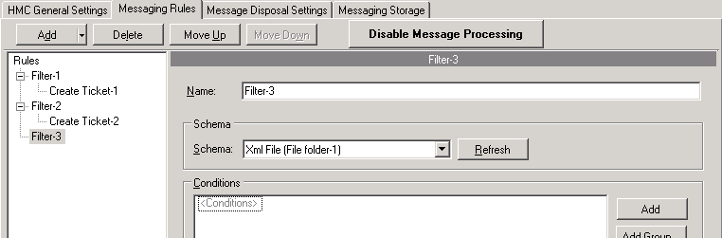

- When creating a condition the variables defined in your XML listener will now be available for evaluation.

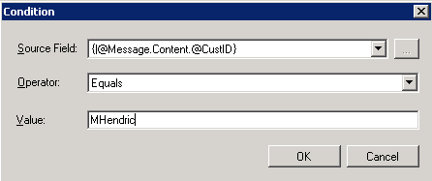

- These same variables will be available to insert into your actions.
- 