NOTE: Before executing the above command it is highly recommended that you backup the log4j library. We have performed initial testing in order to provide mitigation steps quickly and do not expect impact to the logging server or logging events. We are prioritizing the development and release of the hotfix over additional testing of mitigation. If you see impact, the mitigation can be reverted by restoring the backup of the log4J library and restarting the appliance.

- Take a full backup of the appliance configuration before starting:
  - Logon to the admin console as the appliance user or a File Director administrator: https://<appliance>:8443/
  - Browse to Home Tab | Backup & Restore Tab
  - Click on Download Snapshot
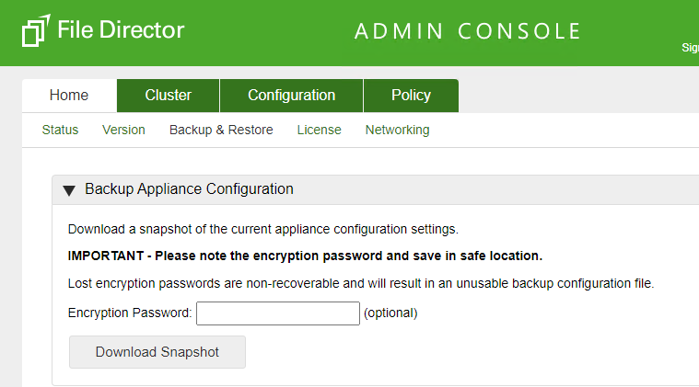
- Take a backup of the appliance using a backup tool.
- Where possible, take a snapshot of the appliance using the Hypervisor snapshot facility. This will allow the appliance to be quickly restored, by reverting to the snapshot.
- To enable Support Mode and SSH
  - These steps will be required for every appliance.
  - Logon as the appliance user to: https://<appliance>:8443
  - Configuration Tab | Advanced Tab | SSH Access
  - Tick “Enable access over SSH”
  - Click on Update
  - Browse to: https://<appliance>:8443/diagnostics
  - Under Support Mode, click on “Download support_id file”
  - Raise a case with Ivanti Support requesting Support Mode access.
  - Attach the support_id.bin file(s). Ensure that the files can be easily associated with the appliances. Ivanti Support will provide an activation code for each support_id file. The code is only valid for the appliance that generated the support_id file.
  - After receiving the activation code logon to the diagnostics page by following steps b. and c. above.
  - Under Support Mode, enter the activation code by replacing the text in the “Enter activation code here” with the activation code and click on Activate.
  - To enable the Shell, under Support Mode click on Toggle Shell. The “shell” will show “true” if the shell is enabled.
- Using Putty or another SSH client, make a SSH connection to the appliance:
  - Hostname: <appliance FQDN>
  - User: support
  - Password: the appliance user password
  - At the prompt “For a list of commands type help or ? followed by return.” enter “shell” and press return.
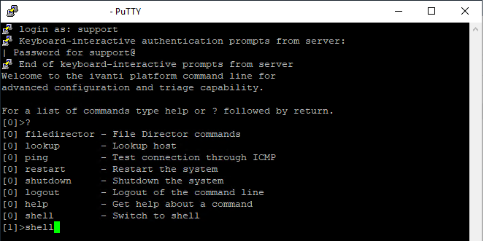

- To elevate the SSH session to the root user:
  - sudo su -
  - Password: the appliance user password
- Run the following commands:
  - Copy each command in turn and paste it into the SSH window. When using a tool such as Putty, the right mouse click is commonly used to Paste.
  - Press enter to execute the commands.

mkdir /tmp/fix
mkdir /tmp/fix/jar
cp /appliance/products/datanow/tomcat/webapps/api/WEB-INF/lib/log4j-core-2.13.3.jar /tmp/fix
cd /tmp/fix/jar
jar xf /tmp/fix/log4j-core-2.13.3.jar
mv /tmp/fix/log4j-core-2.13.3.jar /tmp/fix/log4j-core-2.13.3.jar.bak

rm /tmp/fix/jar/org/apache/logging/log4j/core/lookup/JndiLookup.class

jar cvf /tmp/fix/log4j-core-2.13.3.jar .

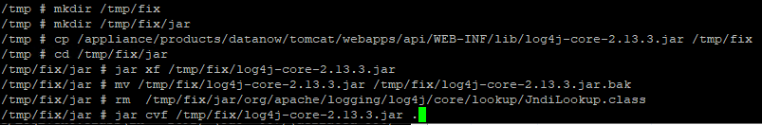

- If the command completes successfully, the output will appear as:

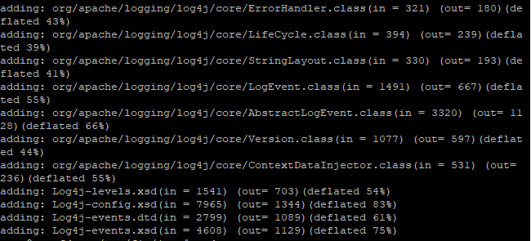

- The final command will create an updated jar file: /tmp/fix/log4j-core-2.13.3.jar. Confirm that the file has been created by running:

ls -l /tmp/fix
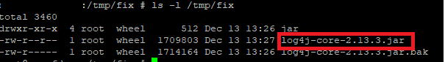
- Copy the new log4j-core-2.13.3.jar file:

cp /tmp/fix/log4j-core-2.13.3.jar /appliance/products/datanow/tomcat/webapps/admin/WEB-INF/lib/log4j-core-2.13.3.jar
cp /tmp/fix/log4j-core-2.13.3.jar /appliance/products/datanow/tomcat/webapps/api/WEB-INF/lib/log4j-core-2.13.3.jar
- Restart the file director server
  - Logon as a File Director administrator or the appliance user to https://<appliance>:8443
  - Home Tab | Status Tab
  - Click on Reboot
- Updating other File Director appliances of the same version
  - Follow the steps above to enable Support Mode, SSH and logon as elevated user.
  - Either run the commands again to generate the jar file, or copy the jar file using scp:
mkdir /tmp/fix

scp support@<appliance with updated jar hostname>:/tmp/fix/log4j-core-2.13.3.jar /tmp/fix

  - Backup the existing file and copy the new file:

cp /appliance/products/datanow/tomcat/webapps/api/WEB-INF/lib/log4j-core-2.13.3.jar /tmp/fix/log4j-core-2.13.3.jar.bak

cp /tmp/fix/log4j-core-2.13.3.jar /appliance/products/datanow/tomcat/webapps/admin/WEB-INF/lib/log4j-core-2.13.3.jar
cp /tmp/fix/log4j-core-2.13.3.jar /appliance/products/datanow/tomcat/webapps/api/WEB-INF/lib/log4j-core-2.13.3.jar

- Update other File Director appliance that are different versions:
  - The jar file is only valid for File Director appliances of the same version.
  - Repeat the steps above to generate a new jar file.

- To verify that the fix is working create an FD session and then send the following URL to the server

https://server/api/folders/${jndi:ldap://example.com/a}

- Download the appliance diagnostics bundle
  - Logon as a File Director administrator or the appliance user to https://<appliance>:8443
  - Home Tab | Status Tab
  - Download Appliance Log and Configuration report bundle
  - Use a tool that can extract tgz files e.g. 7zip
  - Some tools may unzip and extract tar the file in a single step. Other tools you may need to unzip the file first and then run the tool again to extract the tar.
- Review the orca.out log file, which can be found in the dn-app folder.
  - It maybe required to use a text editor that supports UNIX end of line characters e.g. Notepad++.
- Look in the server logs and you should see a line like the following:

INFO [12 Dec 2021 09:50:34,996] [client-exec-6]- ASRequestEventListener.onEvent(94) | 2021-12-12 09:50:34 - - - 80 GET /api/folders/${jndi:ldap://example.com/a} - 400 - - 16 http://192.168.103.12 PostmanRuntime/7.28.4 -

If you see a LDAP connection attempt in any of the logs then the mitigation is not applied correctly.

- Here is an example of what we see before the mitigation is applied in the catalina.out log file:

2021-12-11 21:42:01,932 client-exec-7 WARN Error looking up JNDI resource [ldap://example.com/a]. javax.naming.CommunicationException: example.com:389 [Root exception is java.net.ConnectException: Operation timed out (Connection timed out)]

