LANDesk® Service Desk
Service Desk with Crystal reports

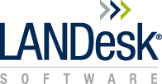
Contents

OVERVIEW - What is Crystal Reports and Crystal Reports Runtime? 4
Crystal reports (designer) 4
Crystal Runtime 4
Less OOTB reports provided in 7.5 – why? 5
USING CRYSTAL REPORT DESIGNER 6
Connecting to the database 6
SQL 32 bit and 64bit 6
Oracle 32bit and 64bit 6
IMPORTANT – Oracle and Crystal on 64bit machines 6
Before you create a report 7
What is Auto Smart Linking in Crystal? 7
Creating a report, adding tables, and linking them 8
Linking the tables 9
Inner Join 9
Left Outer 9
Right Outer 9
Restricting a report to only show certain records 11
Selecting only those Assignments which are Open 11
Prompted selections (parameter fields) 12
Dynamic parameter prompts 14
Creating groups for totals 15
Altering groups 15
Hiding sections of your report- 17
Hide show based on a parameter 17
Basic formulas 18
Datetime to local time (used in the OOTB reports from 7.5) 18
Dealing with NULLS and transforming data 18
Inserting a sub-report 19
Troubleshooting a broken report: 20
Linking 20
Multiple rows / incorrect totals 20
Show SQL 21
CRUFLs 21
Crystal Troubleshooting 23
General 23
Troubleshooting Resources 23
Useful SAP links 23

Information in this document is provided in connection with LANDesk® products. No license, express or implied, by estoppel or otherwise, to any intellectual property rights is granted by this document. Except as provided in terms and conditions for such products, LANDesk Software, Inc. and its affiliated entities (“LANDesk”) assume no liability whatsoever, and LANDesk disclaims any express or implied warranty, relating to sale and/or use of LANDesk products including liability or warranties relating to fitness for a particular purpose, merchantability, or infringement of any patent, copyright or other intellectual property right. LANDesk products are not intended for use in medical, life saving, or life sustaining applications. The reader is advised that third parties can have intellectual property rights that can be relevant to this document and the technologies discussed herein, and is advised to seek the advice of competent legal counsel, without obligation of LANDesk.
LANDesk retains the right to make changes to this document or related product specifications and descriptions, at any time, without notice. LANDesk makes no warranty for the use of this document and assumes no responsibility for any errors that can appear in the document nor does it make a commitment to update the information contained herein.
Copyright © 2007 LANDesk Software, Ltd. All rights reserved.

LANDesk, Peer Download, Targeted Multicast, and Trusted Access are registered trademarks or trademarks of LANDesk Software, Ltd. or its affiliated entities in the United States and/or other countries.
Avocent is a registered trademark of Avocent Corporation.
Other brands and names may be claimed as the property of others.

OVERVIEW - What is Crystal Reports and Crystal Reports Runtime?

Crystal reports (designer)
This is the application where you actually create and modify reports.
This requires separate media to install. Be aware that once you have installed Crystal to a location all other installs (such as Crystal Server) will automatically install to the same location and you can’t change this – make sure you pick a drive with lots of space!
Each customer now has their own Crystal licence key for Designer and Server, provided by the licencing team.

Crystal Runtime
- Installed as a component when you install Console or a Service Desk server.
- When you run a report by clicking on the Report button in Console / Web Access or when running a report via the Crystal component in Console, it will use the Crystal Report runtime. This allows reports to be displayed and printed but not modified.
- On older versions this was previously used Crystal version 10 but we supplied customers with the Crystal XI (11) designer. As a result, we came across many issues where people designed their reports to take advantage of Crystal XI functionality only to find that it didn’t work if they tried to run the report via Console / Web Access. Examples being:
  - Dynamic prompts (or parameter lists)
  - The Shiftdate function (which converts datetime’s based on your timezone in your region settings).
- From Service Desk 7.5 we now use Crystal 2008 runtime in console and web access. When you install Service Desk 7.5 it will automatically install. It shows in add remove programs as “SAP Crystal Reports Runtime for .Net Framework 4 (32bit/64bit)”.

NOTE: Only Crystal Reports 2008 is now supported by SAP. We can move customers up to Crystal 2008 for Designer and Server independently of their Service Desk version (bearing in mind that what they design might not run in the runtime if this is an older version). We can’t upgrade the runtime version unless Service Desk is upgraded.

Less OOTB reports provided in 7.5 – why?
- On-going testing and maintaining all of the reports was becoming more of a challenge. For each 1 report 12 copies would have to be maintained:
  - 1 report x 6 languages (English, French, German, Portuguese, Russian, and now Japanese) x 2 database platforms (SQL and Oracle) =12 reports
  - We originally had 40 OOTB reports x 12 = 480 reports to maintain.
- For this reason, some of the reports had not undergone thorough testing in recent releases and contained errors.
- The reports had been written a long time ago, and so we have now removed any OOTB reports that can be achieved in the product (using grouped queries and dashboards).
- If a customer particular wants an OOTB from an older version of Service Desk we can still send it to them as is (we will not fix issues in that report going forwards).
- Each report has now been more comprehensively detailed in a community article
http://community.landesk.com/support/docs/DOC-23966
- The reports now make use of the ShiftDate functions so when running the reports they will pick up the user’s local time zone(except on Web Access which will pick up the web servers time zone).
http://community.landesk.com/support/docs/DOC-11762
- The only exception to this is the Autoemail report which would be better to have a hardcoded offset from UTC plus perhaps could be modified to also add additional report columns to display other timezones:
http://community.landesk.com/support/docs/DOC-3856

USING CRYSTAL REPORT DESIGNER

Connecting to the database

SQL 32 bit and 64bit
- OLEDB
  - Recommended because no additional setup is required on each machine. Uses the SQL drivers installed via MDAC (Microsoft Data Access Components). You can check the version of MDAC installed using the MDAC checker
http://www.microsoft.com/en-gb/download/details.aspx?id=1953
  - There are more details on setting up OOTB reports using SQL OLEDB in this guide:
http://community.landesk.com/support/docs/DOC-19090
- ODBC
Needs setting up on each machine so not recommended. Also uses MDAC. Depending on the driver, this may store database connection passwords for you so some people use this for this reason:
  - ODBC is accessed via control panel
  - On 64 bit machines you must run ODBC32 because Crystal is a 32bit application (although Crystal 2008 is supported on 64bit).
  - User DSNs are only for the currently logged in user. System DSNs are machine wide.

Oracle 32bit and 64bit
- Again you can use OLEDB or ODBC but OLEDB is recommended.
- Must have the Oracle client installed on every machine which needs to run reports. However, when running through the client you should be able to just check the CUSTOM option and then just the components needed such as OLEDB connectivity.
- There are more details in this guide:
http://community.landesk.com/support/docs/DOC-20781

IMPORTANT – Oracle and Crystal on 64bit machines
- The problem we have found with Oracle 11 on 64 bit machines is that you would ordinarily install 64 bit oracle client but Crystal wants to use an Oracle 32bit OLEDB driver because it is a 32 bit application. So in order to connect Crystal to an Oracle database on a 64bit machine the SAP Crystal forums currently seem to indicate that you need to install 32bit Oracle client tools.

- If you already have 64bit Oracle client installed, (and it needs to remain), you can install the 32bit Oracle client tools alongside. Just ensure that you specify a different Oracle Home path when you install the 32bit client. I then copied the TNSnames.ora :
  - from \app\administrator\product\11.2.0\client1(or where your 64 bit oracle home is)\network\admin
  - to \app\administrator\product\11.2.0\client2(or where your 32bit oracle home is)\network\admin (note I had to create an admin folder as one didn’t exist).

Before you create a report

What is Auto Smart Linking in Crystal?
- When you add tables into your report Crystal tries its best to guess how the tables link together. It looks for primary keys, columns which must be unique, and columns with the same data type then tries to join the tables for you. This very rarely works correctly.
- At least 50% of the report design issues we see within support are due to incorrectly linking tables together. Later we will go through how to fix a report that has incorrect links.
- Before we start adding in any tables to the reports we will switch off Autosmart Linking.
- Go to File – Options – Database, untick Autosmart Linking and also switch on Sort Fields Alphabetically because this makes columns easier to locate:

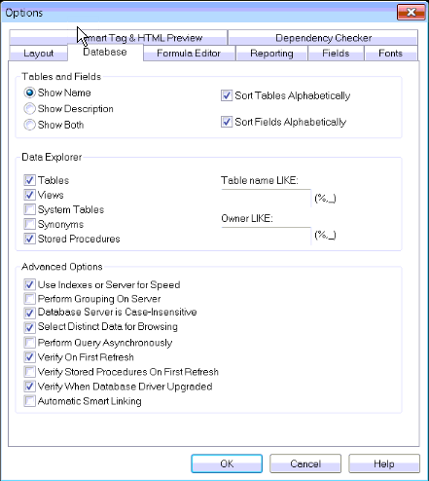

Creating a report, adding tables, and linking them
- File – New – Blank Report
- Create New Connection – OLEDB – OLEDB Provider for SQL Server
- Type in database connection details (supplied)
- You are then prompted to expand your connection details and select which tables you want for the report:
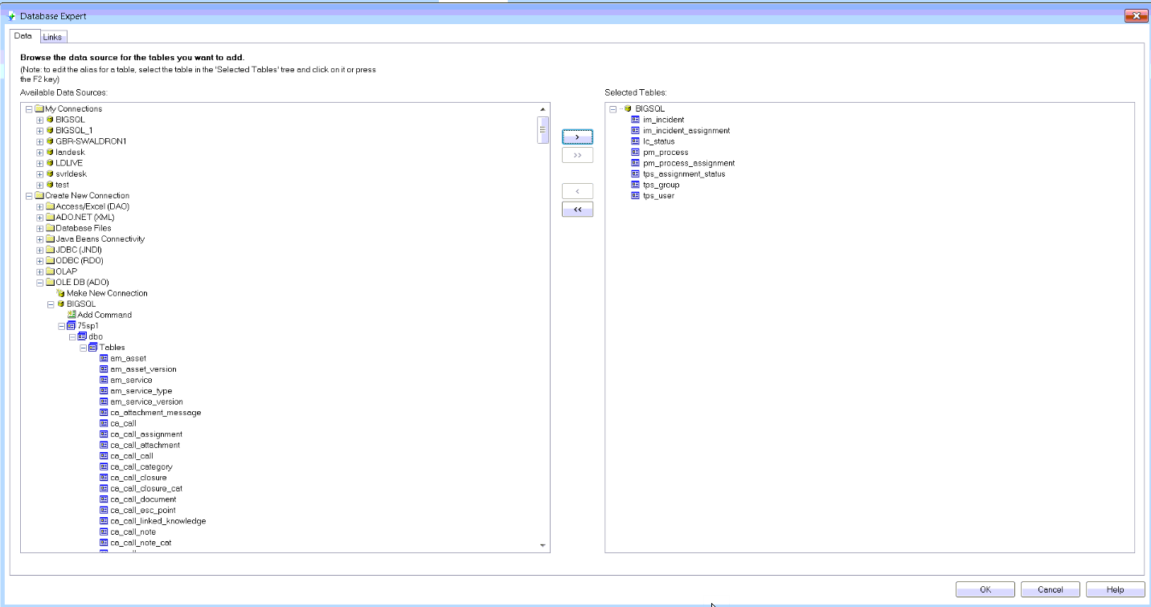
HINT: To get back to this screen in order to add tables in later on go to Database – Database Expert.
HINT: In most cases the first table customers will want is pm_process because this holds creationdate, title and description. Most customers report on process information to calculate percentages that they can’t get from queries.

- As we are reporting on incident assignments please add:
IM_INCIDENT – incident level data such as impact, urgency, response level, severity, category, etc..
IM_INCIDENT_ASSIGNMENT – This table only contains guids for assignments for incidents whereas process assignment holds all assignments. This table is added just to restrict the records to incident assignment records only.
PM_PROCESS – process level information such as date created, title and description
PM_PROCESS_ASSIGNMENT – contains the information about the assignment such as the date it was created, holds a link to which user/ group it was assigned to and a link to what status it is at currently.
TPS_GROUP – We’ve added this to show who the group was who was assigned to.
TPS_USER – We’ve added this to show who the user was who was assigned to.
TPS_ASSIGNMENT_STATUS – Add this so you can show only the active assignments for an incident.
LC_STATUS - Holds the current status of the process

Linking the tables
When using more than one table within a report you must link the tables together to show how they relate to each other.
In Crystal there are 3 main types of link but Inner and Left Outer are used most often. Again a very large amount of the support calls we get about reporting are caused by customers selecting the wrong type of join for their tables.

Inner Join
An Inner join is the standard type of join. The result set from an Inner join includes all the records in which the linked field value in both tables is an exact match.
Use this type of join when you know that for the purposes of the report you want only records where a record exists in both tables. For example, in a report about incidents when I link the pm_process table to the im_incident table I know that the pm_process table holds other records about other processes but I don’t want these for my report. So I can link the two tables using an Inner join and therefore I will only get records from pm_process where there is a matching record in im_incident.

Left Outer
The result set from a Left Outer join includes all the records in which the linked field value in both tables is an exact match. It also includes a row for every record in the primary (left) table for which the linked field value has no match in the lookup table.
Use this type of join when there is a possibility that a field might’ve been left blank (it is not mandatory at database level). For example, on a report about incidents you want to know the impact of the incidents so you want to link im_incident to im_incident_severity. However it is possible that some incidents don’t have a severity on them. If you left the link as an Inner Join, incidents with no severity would not show on the report. If you make this a Left Outer (with im_incident on the left linking to im_incident_severity on the right) then you would also see incidents with a blank severity.

Right Outer
(This is not often used) The result set from a Right Outer join includes all the records in which the linked field value in both tables is an exact match. It also includes a row for every record in the lookup (right) table for which the linked field value has no match in the primary table.
TIP: Always place the main tables for your report on the left of the screen when linking tables so the tables which hold additional information are on the right and you can link them using a Left Outer join.
Links:

im_incident –Links to pm_process via the pm_guid. All incidents have a process so can use an Inner Join.
lc_status – Links to pm_process via pm_process.pm_status_guid to lc_status.lc_guid. All processes have a status so can use an Inner Join.
im_incident_assignment – Links to im_incident via im_incident.pm_guid to im_incident_assignment.im_incident_guid. In this report I want to only see incidents which have had an assignment so I can use an Inner Join.
pm_process_assignment -. Links to im_incident_assignment via pm_guid. All incident assignments have a corresponding record in process assignment so I can use an Inner Join.
tps_group – Links to pm_process_assignment via pm_process_assignment.pm_group_guid to tps_group.tps_guid. Some assignments may only specify a user and not a group if this is not mandatory so I will use a Left Outer Join.
tps_user - Links to pm_process_assignment via pm_process_assignment.pm_user_guid to tps_user.tps_guid. Some assignments may only specify a group and not a user if this is not mandatory so I will use a Left Outer Join.
tps_assignment_status – Links to pm_process_assignment via pm_process_assignment.pm_status_guid to tps_assignment_status.tps_guid. All assignments have a status so can use an Inner Join.
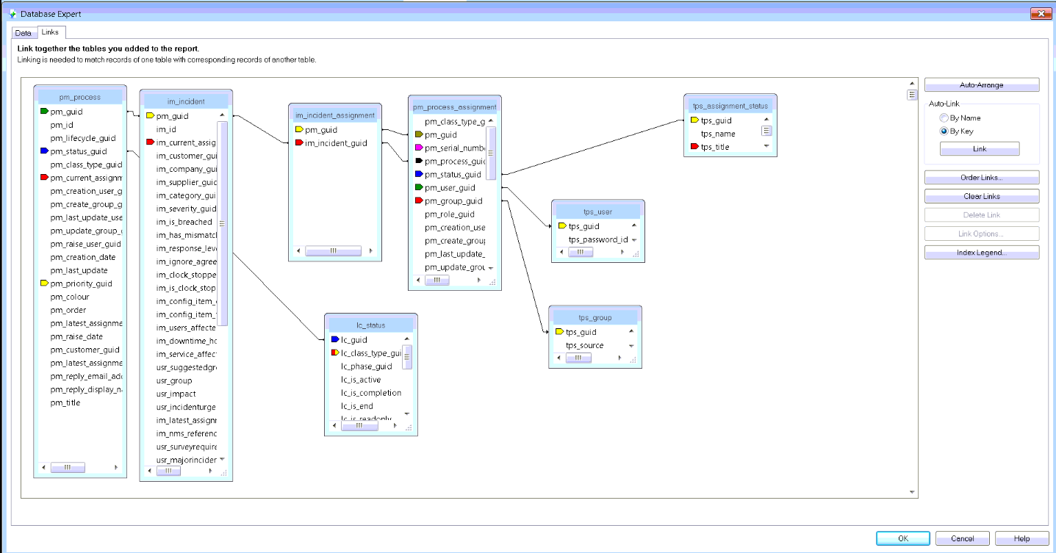
HINT: To get back to this screen in order to add tables in later on go to Database – Database Expert – Links tab.
In order to change a link type, draw the link and then select Link Options.

Restricting a report to only show certain records

In order to show information on your report drag the field into the Details section from the field explorer.
TIP: If field explorer isn’t showing go to View – Field Explorer.
Add im_incident.im_id , pm_process.pm_title and lc_status.lc_title onto your details:
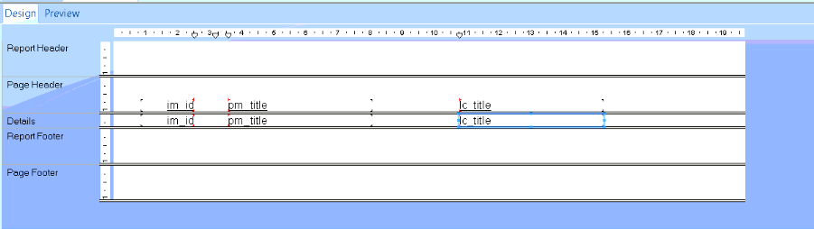
Press F5 to run the report.

Selecting only those Assignments which are Open

Drag tps_assignment_status.tps_title onto the report and then select it. Go to Report – Select Expert – Record. The field you want will already be selected:
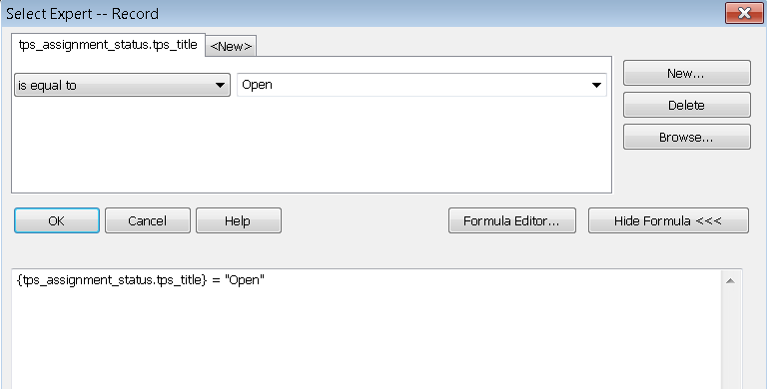
Click “Is Equal to” and then select Open from the list of values.

Prompted selections (parameter fields)
In field explorer create a new Parameter Field called Select Status.
IMPORTANT: It is very important here that you select the Type which matches the attribute type which you will be selecting from Service Desk. If you get this wrong your parameter field will not show in your list later on.
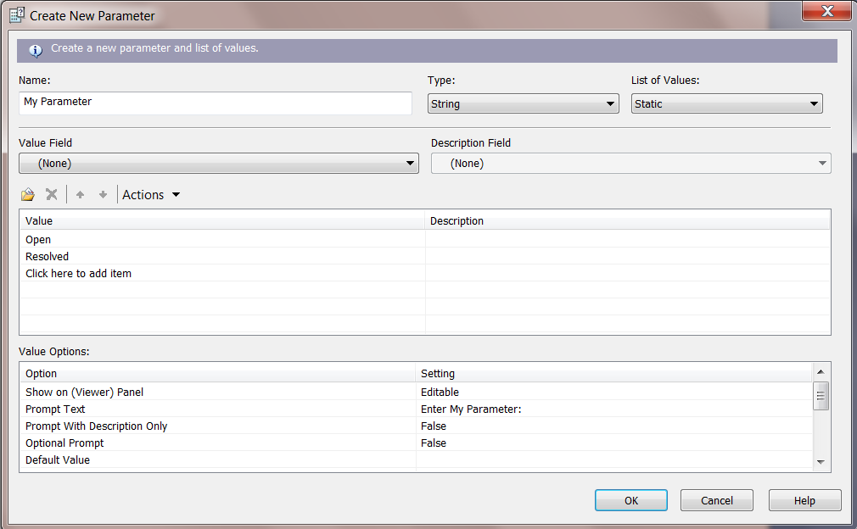
In this instance we will type in the values manually. Add the values:
Open, Resolved, In Progress
Now we need to change how we restrict the data in the report so that this is based on what we select from the parameter when the report runs. Highlight lc_status.lc_title and go to Report – Select Expert – Record. Change the Open value under Is Equal To and select the Parameter that you have created.
NOTE: If your parameter doesn’t show in this list it has been created with the wrong “type”.
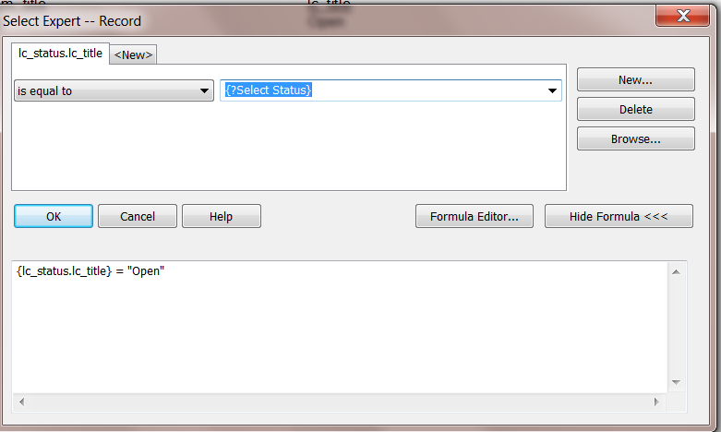
Press F5 to run the report.

Dynamic parameter prompts
Instead of manually typing values into the parameter you can select to pre-fill them straight from the database values. This is now possible in Service Desk 7.5 but on older versions using Crystal X (10) runtime the prompt would not show any values when running the report from within Service Desk.
To set this up open your parameter and change the List of Values to being Dynamic. Next under the Value section select lc_status.lc_title and you must ensure you click on “Click To Create Parameter”:

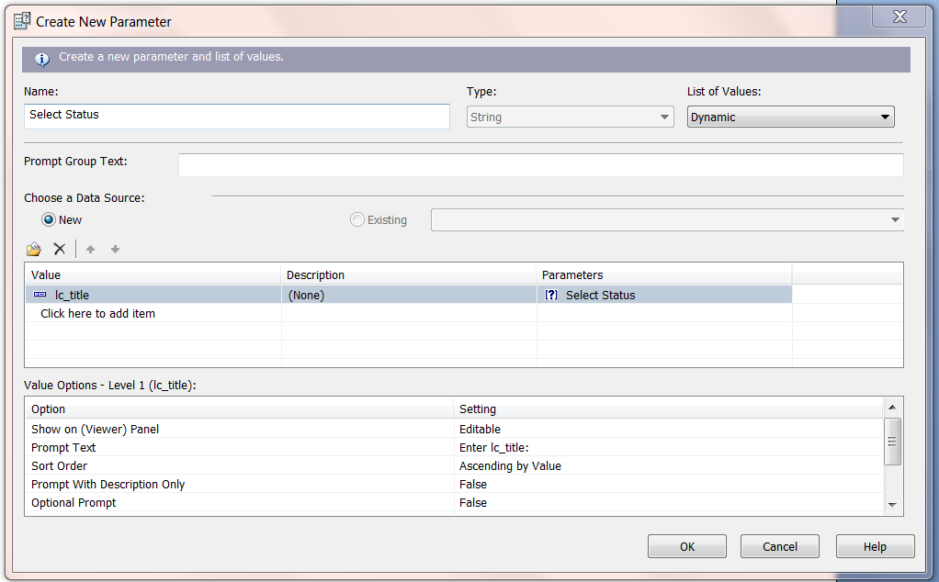
Now when running the report you will be able to select the values from the lc_status.lc_title column in the database.

Creating groups for totals

Now we are going to group the report by which support group it is currently assigned to. To do this we select the item which is unique about each record (this is just good practice and is im_incident.im_id on this report) and select Insert – Summary.

Set “Calculate this summary” equal to Count so that we count how many incidents each group has.
Click the Insert Group button and select tps_group.tps_title.
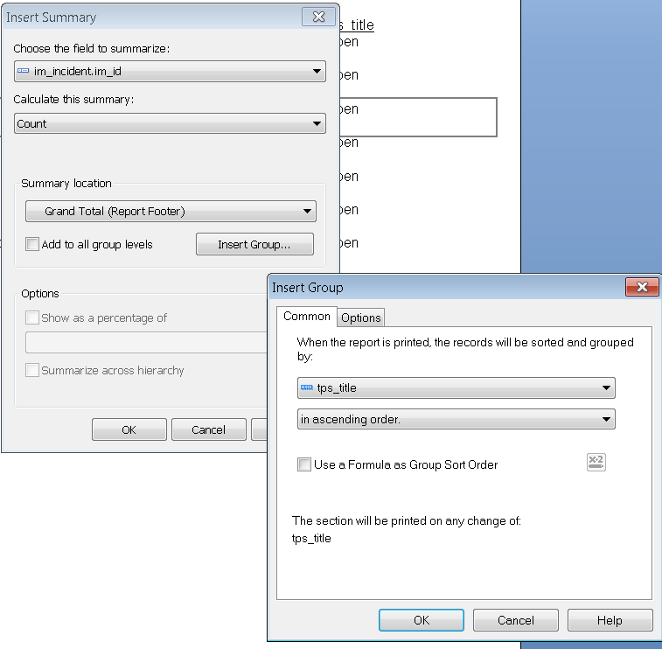

Altering groups

Notice how the group shows on the margin. When you have more than one group you can drag around the order to total and subtotal in different ways. Right-click on the group and select Change Group. Select tps_user.tps_title.

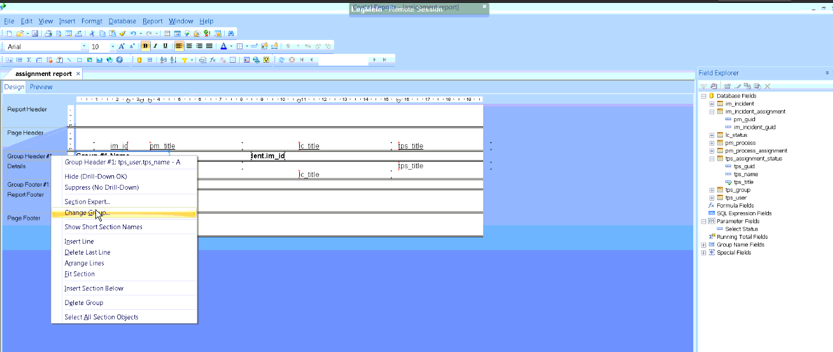

Hiding sections of your report-
You can hide and show sections of your report by right-clicking on the section within the margin and selecting Hide or Suppress. You might want to do this to only show the totals of a report for example. If you select Hide you can still drill into the details (creates a new tab) but if you select Suppress you can’t.

Hide show based on a parameter

Create a new parameter field which is a type of Boolean. Call it “Hide or Show details?”
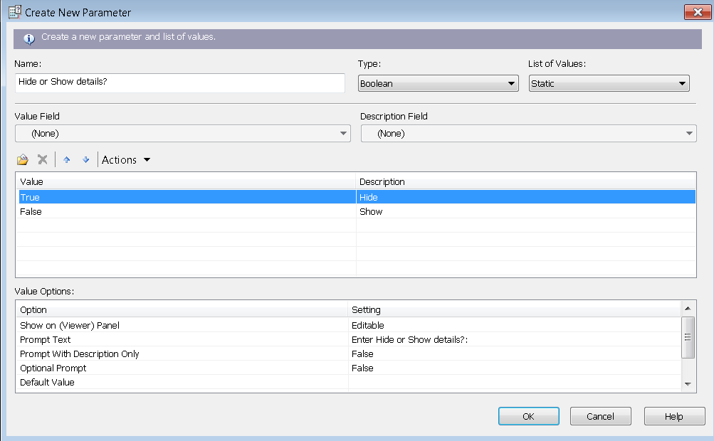

Right-click on the Details section on the margin, select Section Expert, and select the formula button next to Suppress (on the Details section). Pull in the parameter. This will then suppress this section if the person selects Hide/True at runtime.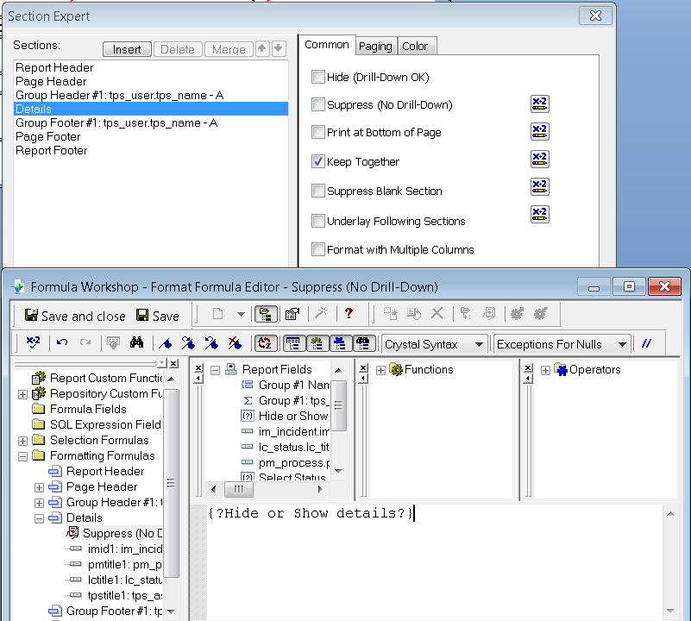

Basic formulas

Formulas can be used to transform the Service Desk data in a way which is more suitable to read. Here are a few basic examples of how they can be used:

Datetime to local time (used in the OOTB reports from 7.5)

Within the field explorer create a new formula and call it DateTime to LocalTime. Expand functions and select Date. Then locate the ShiftDateTime function and drag it into your formula. The formula expects 3 bits of information:
- Field to convert
- Timezone the field is in
- Timezone to convert to
The 3rd value can be left as ‘’ which means “pickup the timezone from my machine”. This works as long as it’s not via the web. So your formula will be:
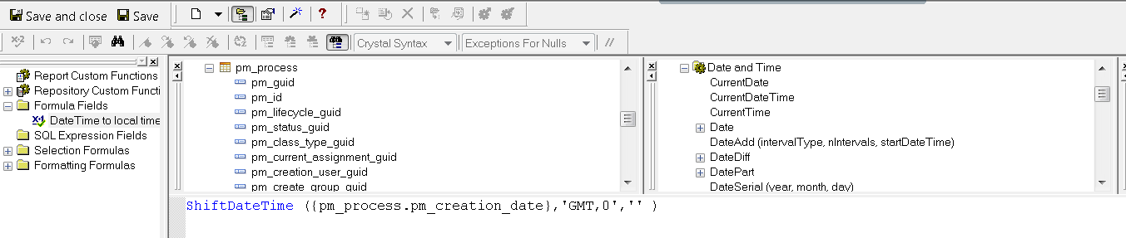
Drag the formula from the field explorer onto the report to view it.

Dealing with NULLS and transforming data

Create a new formula and call it Alter Groups. We are going to change one of the groups on our report from being called Helpdesk to being called IT Helpdesk. The formula would be and if else statement (if this then do x else do y).

If {tps_group.tps_title} = ‘Helpdesk’ then ‘IT Helpdesk’ else {tps_group.tps_title}

Change your report to be grouped by your new formula.

If you want to deal with assignments which don’t have a group (so the field is null) you can use this type of formula:

If IsNULL({tps_group.tps_title}) then “No Group Specified” else
If {tps_group.tps_title} = ‘Helpdesk’ then ‘IT Helpdesk’ else {tps_group.tps_title}

Other common ways to transform data is to change the data type so you can perform different functions with them. For example ToText({fieldname}) or ToNumber ({fieldname}) if you want to do some calculations on a string field which holds numbers.

Inserting a sub-report
A sub report is a report within a report. A sub-report can have most of the features of a normal report. Using sub-reports unrelated data can be combined into the same report.
The differences between a primary and a sub report are:
- Primary reports can have sub-reports but sub-reports can’t have sub-reports.
- Sub-reports don’t have a page header or footer.
- Sub-reports cannot stand on their own and must be part of a primary report.

You can either link the sub-report to the main report or leave it completely unconnected. For example:

- Adding a list of all users in the system into our assignment report would be an unconnected sub-report – it doesn’t need to know about the data within the main primary report.
- Showing a list of all CIs associated with the incidents show on our report - needs to be linked to the primary report in order to know what these records are.

On the Details section select Insert – Subreport and give the report a name.
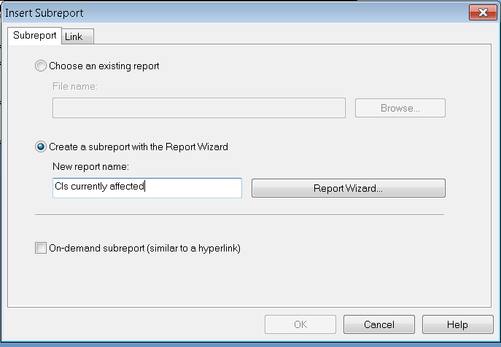
Select im_incident and cf_cinfig_item and link the tables
Select cf_config_item.cf_title and cf_config_item.usr_ipaddress

Click finish. On the link tab select im_incident.pm_guid. This is how it will link the data between your main primary report and the subreport so that only those CIs which are associated with the incidents will be shown.

Click ok and then place the subreport within a new details section.

Troubleshooting a broken report:

Linking

The most common issue with people designing their own reports or adding information to a report is to get the linking wrong or to not switch off the autolinking first. The symptoms are that they “see no data” on the report or no information from the table that they linked.

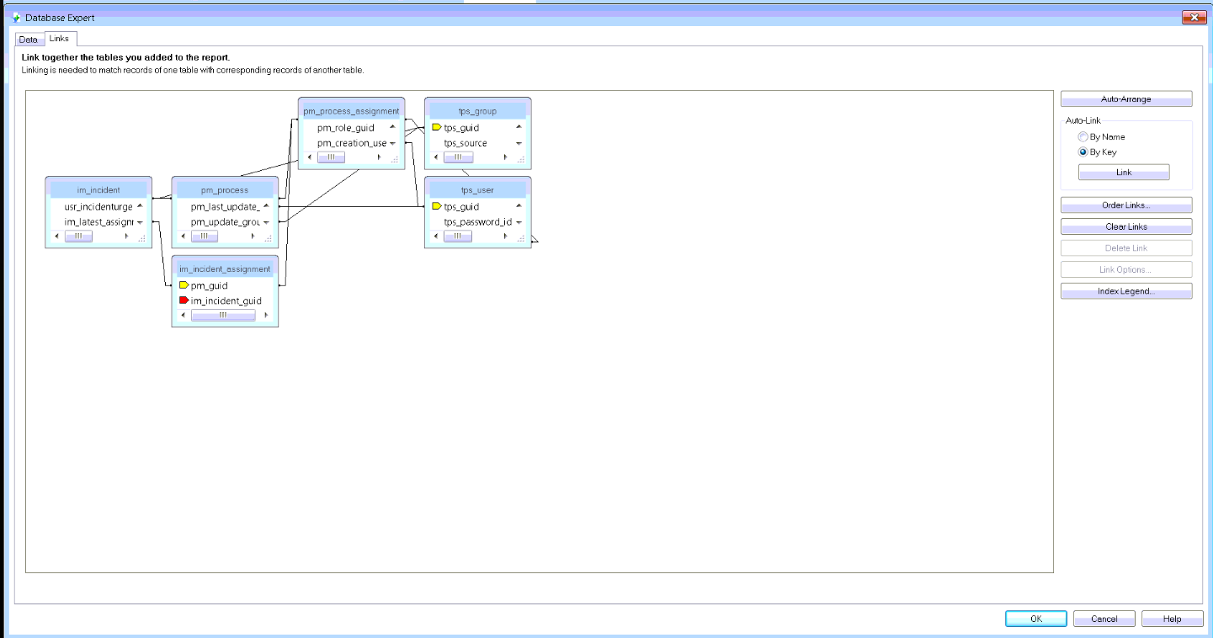

To check this go to Database – Database Expert – Links. If there seems to be multiple links to each table or the linking is obviously wrong this is the problem.

If someone is modifying a report it would be better if they can revert back to an older copy of the report. Then switch off smart linking and add the tables in again creating the links properly.

If not you will need to click the Clear Links button and then manually link all the tables for them.

Multiple rows / incorrect totals

If you are seeing multiple rows displayed on the report (for example some incidents show a couple of times on the report) then look at the data columns they have dragged in. If they have dragged in a column which could have more than one row for an incident such as incident resolutions or escalation points then this will be why. In order to stop showing multiple rows they have a few choices:
- Group the report by incident id and suppress the details section (only showing the group)
- NOTE: If you have ended up with multiple rows on your record per incident, but you for example if you have included incident resolution details and have resolved an incident more than once then for any totals you might want to do a distinct count on incident id which will count only the unique ids.
- Use Report – Select Expert – Record to only select the records that you need. For example only showing the incident escalation points where the is_breach flag is set to true.
- Use a database view to bring back only the latest record – we have some in the database and on community which only bring back the max (max escalation point and max resolution)

Show SQL

If you want to see what records the report is selecting (useful when troubleshooting performance issues with a report) you can use Database – Show SQL Query. You can then copy this and paste it to run the query against the database.

CRUFLs

We used a function earlier to transform the date into a local date (ShiftDate). Crystal Reports allows you to create your own custom function libraries. These custom libraries are known as User Function Libraries (UFL) and we refer to them as CRUFLs (Crystal User Function Libraries).

Some of the Service Desk OOTB reports use CRUFLs. These are the Breaching in Next N Hours and the Incident Duration report. We also provide some CRUFLs that customers can use in order to create their own reports.

The CRUFLs perform calculations which would be difficult for a customer to calculate themselves. For example the function IncidentDurationIncidentDurationGetDuration is used to work out the business hours for an incident between the time it was opened and resolved or closed. This takes into account working hours, non-working days, public holidays and “stop the clock”.

The problem with CRUFLs is that they need to be installed on each machine which will be running the report. We supply a batch file to register the files so that Crystal can “see” them. The batch file uses something called GACUtil and regasm to register the files on the local machine.

The Global Assembly Cache (GAC) enables you to share assemblies across numerous applications. The GAC is automatically installed with the .NET runtime. Components are typically stored in C:\WINNT\Assembly. Gacutil is the Global Assembly Cache tool and this allows you to view and manipulate the contents of the global assembly cache and download cache. It is installed if you install the .net SDK.

Regasm is the Assembly Registration tool which reads the metadata within an assembly and adds the necessary entries to the registry, which allows COM clients to create .NET Framework classes transparently. Once a class is registered, any COM client can use it as though the class were a COM class. The class is registered only once, when the assembly is installed. Instances of classes within the assembly cannot be created from COM until they are actually registered.

You can tell if the CRUFLs have not registered properly in the following ways:
- You see the error “some formulas failed to compile” when opening the report.
- When running the report you see the message “The Visual Basic UFL that implements this function is missing”
- When running the report you see the message “U2lcom.dll is missing. "
- If you look at the formula which references the function the function is showing in black (not recognized) rather than blue.

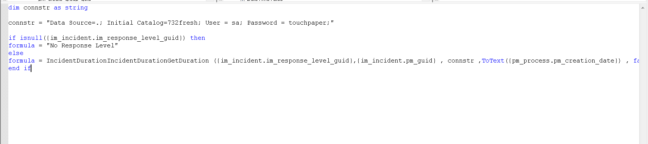

If running the batch file (reg_crufl.bat) doesn’t fix the issue it may be that the versions of regasm and gacutil on the machine are not correct for:
- The version of .net framework
- The platform – even on a 64bit machine you need to use the 32bit version of the files because Crystal is a 32bit application.

This is the troubleshooting doc I wrote about how to correct this:
http://community.landesk.com/support/docs/DOC-24897

Crystal Troubleshooting

General
- If you are hitting an issue in Console / Web Access, if possible try running the report in Crystal Report Designer.
- Try either removing one part of the report at a time until the issue is resolved. For example removing groups, fields on the report, tables etc..
- Here is an article about how to troubleshoot a report which is not bringing back the expected records:
http://community.landesk.com/support/docs/DOC-6983

Troubleshooting Resources
- LANDesk Community area for Reporting
http://community.landesk.com/support/community/servicedesk/reporting
- The Reporting Landing Page has links to the most well used articles:
http://community.landesk.com/support/docs/DOC-26156

- SAP support (knowledge base, supported platforms etc)
http://www.sdn.sap.com/irj/boc/support
- SAP forums
http://forums.sdn.sap.com/forum.jspa?forumID=316
- As Crystal reports is a very widely used product you also find lots of advice if you google for help and there are even a number of instructional videos on Youtube.
- Some members of Support are also able to raise support issues directly with SAP (only if we believe it is a support issue not for advice on how to design a report of a certain type). SAP will not provide support on Crystal XI as it is EOL. SAP will always want the customer on the latest service pack before they progress the support issue.

Useful SAP links

- Supported Platforms for 2008
  - http://www.sdn.sap.com/irj/boc/go/portal/prtroot/docs/library/uuid/e090690e-847a-2c10-70be-c46466fad425?QuickLink=index&overridelayout=true&44929653278675
  - Installation Guide
  - http://help.sap.com/businessobject/product_guides/crs2008V1/en/crs_08_v1_inst_win_en.pdf
  - http://help.sap.com/businessobject/product_guides/crs2008/en/CRS2008_quickinstall_windows_en.pdf
- EOL announcement
  - http://www.sdn.sap.com/irj/boc/index?rid=/webcontent/uuid/c018fb0e-8724-2b10-c489-9b8333e5e0f9

